BUG Figure Reference Disappears When Field is Updated:
TEST Table
Table 1 Test Table Caption
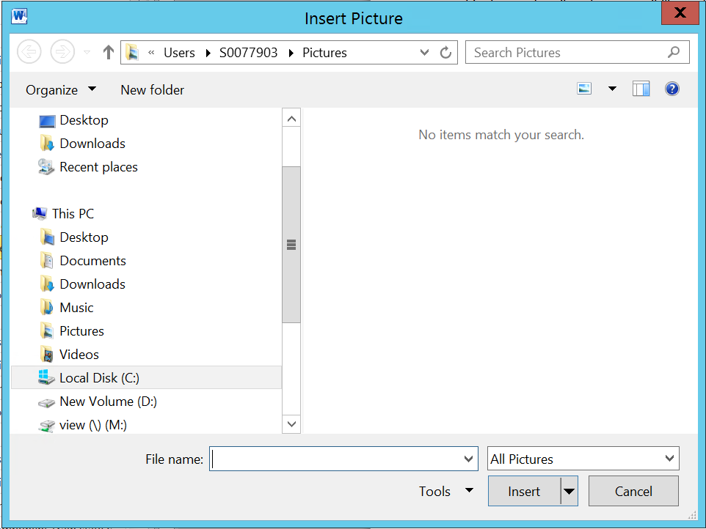
Figure 2 Test Figure Caption
References: Update Field Removes the Reference
Table : Table 1 Test Table Caption
… as hyperlink :Table 1 Test Table Caption
Figure : Figure 2 Test Figure Caption
… as hyperlink : Figure 2 Test Figure Caption

